

KAAH INTERNATIONAL ACADEMY
Class: | __3___ | Subject: | _________ | Exam: | END SEM Exam | Academic Year: |  |  | 2025-2026
Name: |  |  |  |  |  |  | Date: | …../10/2025

PART 1 ANSWER ALL THE QUESTIONS
Write in words
1. 200_____________________
2. 50______________________
3. 110_______________________
ADD
4. 164 + 3 = 5. 276 + 2 = 6. 321 + 5 =

ADDITION OF FRACTIONS
7.$\frac{5}{7}$+ $\frac{1}{7}=$ 8. $\frac{2}{5}$+ $\frac{1}{5}=$ 9. $\frac{5}{9}$+ $\frac{1}{9}=$
ADD
10. 6 + 4 + 3 = 13. 5 + 3 + 5 =

12. 2 + 5 + 6 = 14. 6 + 4 + 5 =

Multiply
15. 5 × 3 = 16. 2× 3 = 17. 3 × 3 =
Divide
18. 8 ÷ 2 = 19. 9÷ 3 = 20. 10 ÷ 2 =

ADD
21). 3 5 5 22). 8 2 6 23) 4 5 5
+ 3 4 4 + 1 6 3 + 3 5 3

SUBTRACT (TAKE AWAY)
24) 7 8 4 25) 4 5 6 26) 8 7 9
- 4 2 3 - 2 3 4 - 4 5 4

SUBTRACTION OF FRACTIONS
27.$\frac{8}{10}$- $\frac{7}{10}=$ 28. $\frac{3}{8}$- $\frac{2}{8}=$ 29. $\frac{3}{7}$- $\frac{2}{7}=$

Write a fraction
30  = 31  = 32 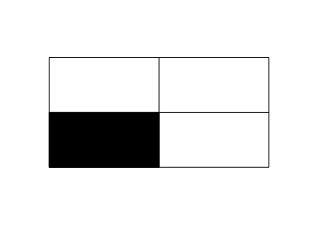=

$\frac{1}{2}$ of a group

33. $\frac{1}{2}$ of 4 = 34. $\frac{1}{2}$ of 6 = 35. $\frac{1}{2}$ of 8 = 

